Class: EE3501

Assignment: Lab 2

Professor: Craig A. Chin

Student: Goran Novakovic

Prelab:

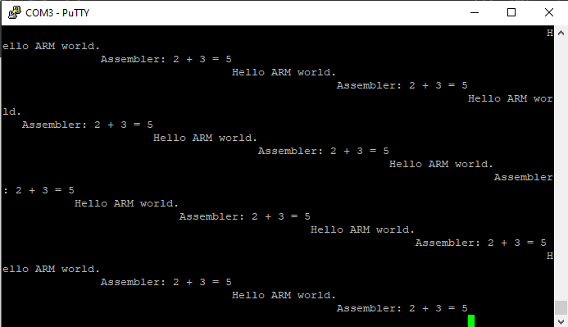

Figure 1: Terminal output from Lab 2 prelab section.

Lab Results:

LED is blinking and outputting from original code 300ms as time delay. When the code was edited to reduce the delay to 188ms and 37ms the ratio has stayed in the range between 2.703 and 2.666 giving the average ratio of 2.676.

Derivation:

$$Ratio=\frac{Number after x in the code}{\begin{aligned}Time dellay in microseconds \\ \end{aligned}}$$

State:

Theoretical 1ms would be reached by using 0x00002676

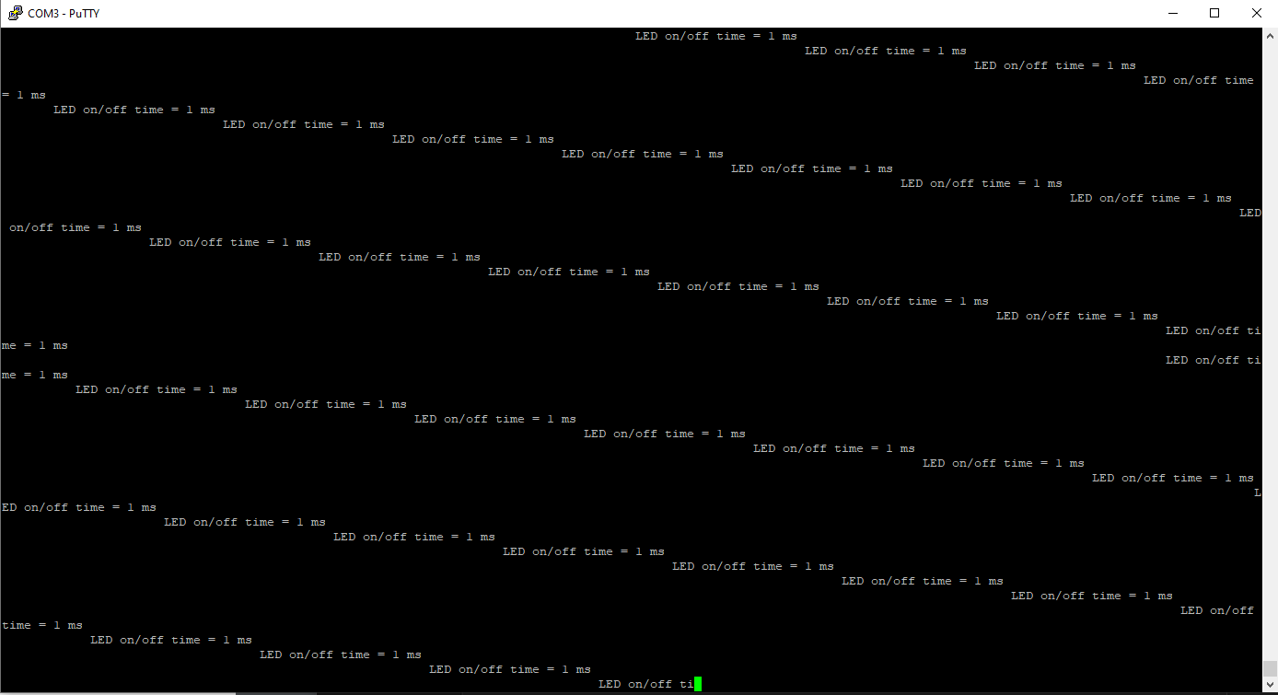

Figure 2: 1ms delay timer was reached using theoretical ratio.

Discussion:

Discussion:

1. Explain what every assembly instruction does in the code used in this lab.
   1. PROC – States the beginning of the procedure
   2. AREA – creates a block of data for the code defined
   3. EXPORT – Creates a symbol that can be recognized by other files
   4. SUBS – subtract from the current value and store it
   5. ALIGN – make sure the code and data fit in the memory boundary
   6. MOV – moves a bit of code to the memory
   7. BNE – a type of loop stating to loop the equation back to the word defined
   8. BX – exchange branches
   9. ENDP – the end of the code
   10. END – the end of the file
   11. LDR – load data in specified address
   12. LOOP – block of statements that are repeatedly executed
2. What is the longest delay you can achieve with the coed in part 4?

The longest delay you can achieve is 5758ms shown in figure 3

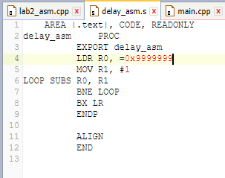

Figure 3: longest delay in part 4 of lab 2 manual.

1. Based on the measured data, calculate the exact clock rate in MHZ of your ARM core processor.

$Clock rate= \frac{1}{Clock Cycle}$ Clock cycle = 6 cycles

* + 1. Clock rate = .167

1. If you were to change the name of the asm file, where in the code would you have to edit to make this work?

If you changed the name “delay_asm.s” file, you would have to change the main.cpp file where it says “extern “C” void delay_asm(void);” and in the while loop that states “delay_asm(); myled = !myled;’